

Part - 2 : Multiple Operations with Matrices using OpenMP

Student Id : 2407710
Student Name : Dhadkan K.C.
Group : L6CG4
Lecturer : Mr.Yamu Poudel

Table of Contents
Overview 1
How to Compile and Run 1
Compile 1
Run 1
Input / Output Files 1
Solution Explanation (Detailed) 2
Word Definition (Token Rule) 2
Multithreading Approach 2
Dynamic Slicing (Load Balancing) 3
Synchronization (Thread Safety) 3
Partial Words at Slice Boundaries 3
Sorting and Writing Output 3
Results and Screenshot 3
Matrices 3
MatData 7
Limitations and Notes 10
Source code 11
Code Structure Overview 15

Overview
The current project is related to the work on the creation of a multithreaded C program, using the OpenMP shared-memory parallelism with its specific adaptation to perform various mathematical operations on the matrices with increased efficiency. The application takes in more than one matrix in a text file as specified by the user, which is dynamically allocated during the process of the application and processes them in pairs. A wide range of operations are implemented depending on whether matrix dimensions are compatible or not.
The key goal of this research is to utilize the concept of shared-memory parallelism to accelerate computation-intensive tasks in a matrix such as the ability to manipulate elements individually, and the ability to multiply two categories of matrices. The use of multi-core processors, the ability to allow users to specify the number of threads at run-time, and the ability to maintain computational accuracy and numerical stability all demonstrate the scalability of the program and the efficient use of multi-core processors.

How to Compile and Run

Compile
gcc teask2_advanc.c -o Task2 -fopenmp -lm

Run
./Task2 <inputfile.txt> <threads>
Example
./Task2 MatData.txt 8

./Task2 Matrices.txt 8

- <inputfile.txt> specifies the matrix data file.
- <threads> defines the number of OpenMP threads to use.
- The output is written to Task2_Matrices_12.txt.

Input / Output Files
Input File
The input is a plain text file that contains pairs of matrices.
Each matrix is described in the following format:
- Matrix dimensions given as
- rows,columns
- Matrix elements listed in row-major order, where each row is written on a new line and values are separated by commas.
The file contain multiple matrix pairs, and the program continues reading and processing each pair until the end of the file (EOF) is reached.
Output File
Output File Name:
Task2_Matrices_12.txt
Task2_MatData_12.txt
The output file contains the results of all valid matrix operations performed on each matrix pair (such as addition, subtraction, or multiplication, depending on compatibility).
- For valid operations, the resulting matrix is written to the file with proper formatting.
- For invalid operations (for example, incompatible matrix dimensions), a descriptive error message is written instead.
- The program does not terminate on invalid input; it continues processing the remaining matrix pairs in the file.

Solution Explanation (Detailed)

Word Definition (Token Rule)
In the given task, the concept of a word is replaced by individual numerical values that collectively form a matrix. All numerical values in the input file are treated as tokens of type double. The matrix dimensions act as a structural constraint, requiring the grouping of these tokens into rows and columns. This interpretation ensures that all numerical data is processed strictly according to the matrix format and in compliance with the specified operational requirements.

Multithreading Approach
The application utilizes OpenMP directives to parallelize matrix computations. The directive #pragma omp parallel for is applied to loops that iterate over the rows and columns of the matrices. Each thread is assigned a unique subset of matrix elements or rows, making this approach well-suited for shared-memory parallel architectures. As a result, significantly reduced execution times are achieved for large matrices, while the implementation remains simple and easy to understand.

Dynamic Slicing (Load Balancing)
Automatic load balancing is achieved through OpenMP’s dynamic loop scheduling mechanism. In addition, a thread-limiting strategy ensures that the number of threads does not exceed the number of rows available for processing. This prevents over-threading and guarantees that each thread performs useful work, which is especially important when matrices are small or have uneven dimensions.

Synchronization (Thread Safety)
In this implementation, explicit synchronization primitives such as mutexes are not required. OpenMP threads operate on distinct portions of the matrix, ensuring that concurrent access to the same memory location does not occur. OpenMP internally manages shared and private variables, thereby preventing race conditions without the need for manual synchronization.

Partial Words at Slice Boundaries
In matrix processing, the issue of partial data arises only when matrices are arbitrarily sliced. To avoid this problem, each matrix is read completely according to its defined dimensions before any computation begins. This guarantees that matrix elements are never split across threads or operations, thus preserving data integrity throughout the computation.

Sorting and Writing Output
Unlike traditional word-based tasks, sorting is not applicable to matrix operations. Instead, the computed results are formatted in a clear and tabular structure and written to the output file. Each matrix operation is identified with an appropriate label, and the resulting values are displayed in row-wise format. Numerical anomalies, such as those resulting from division by zero, are represented as NaN, making undefined values explicit and easily identifiable.

Results and Screenshot
The program was executed four times using two different input files and varying numbers of threads:

Matrices
- Input file : Matrices
- 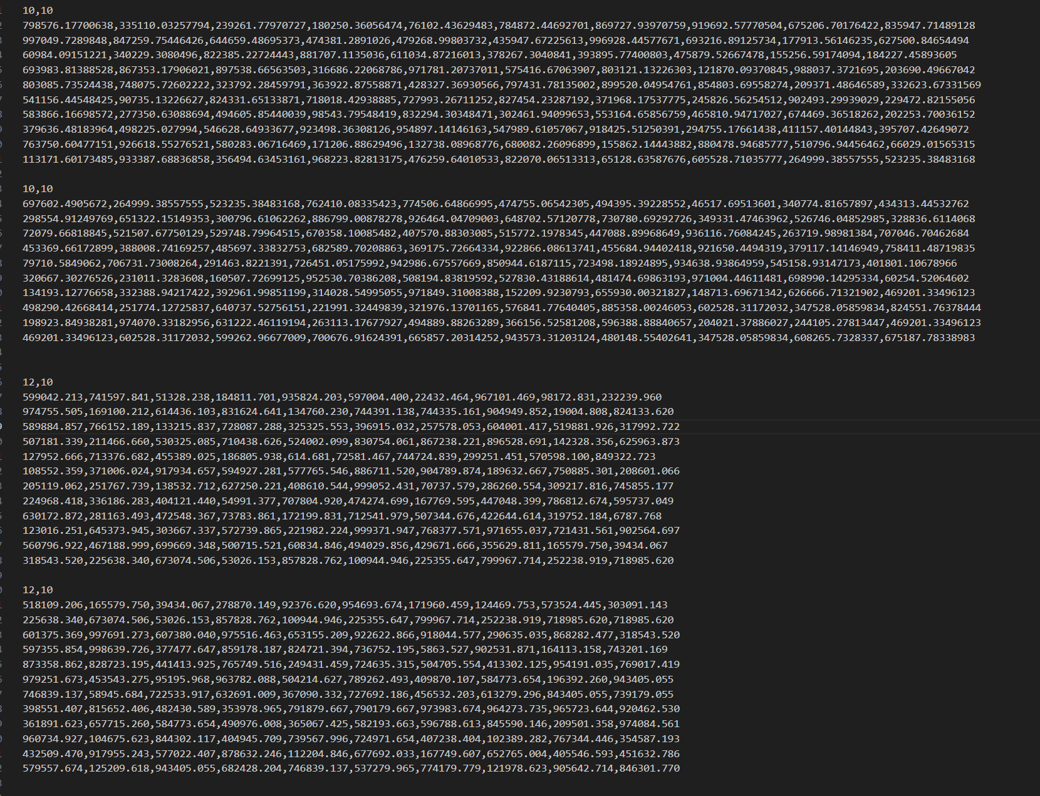

- Matrices.txt with 12 threads
- 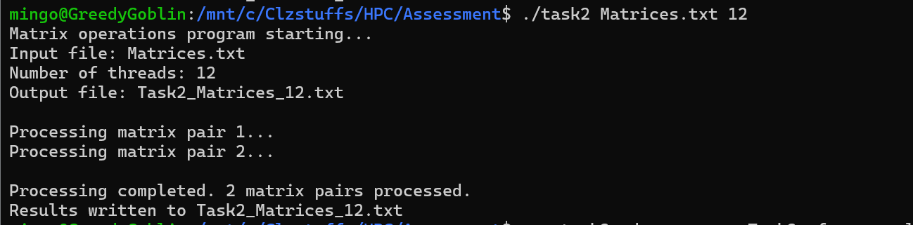

- Matrices.txt with 2 threads
- 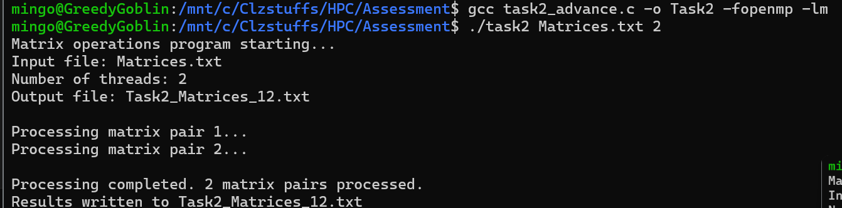

- Output:
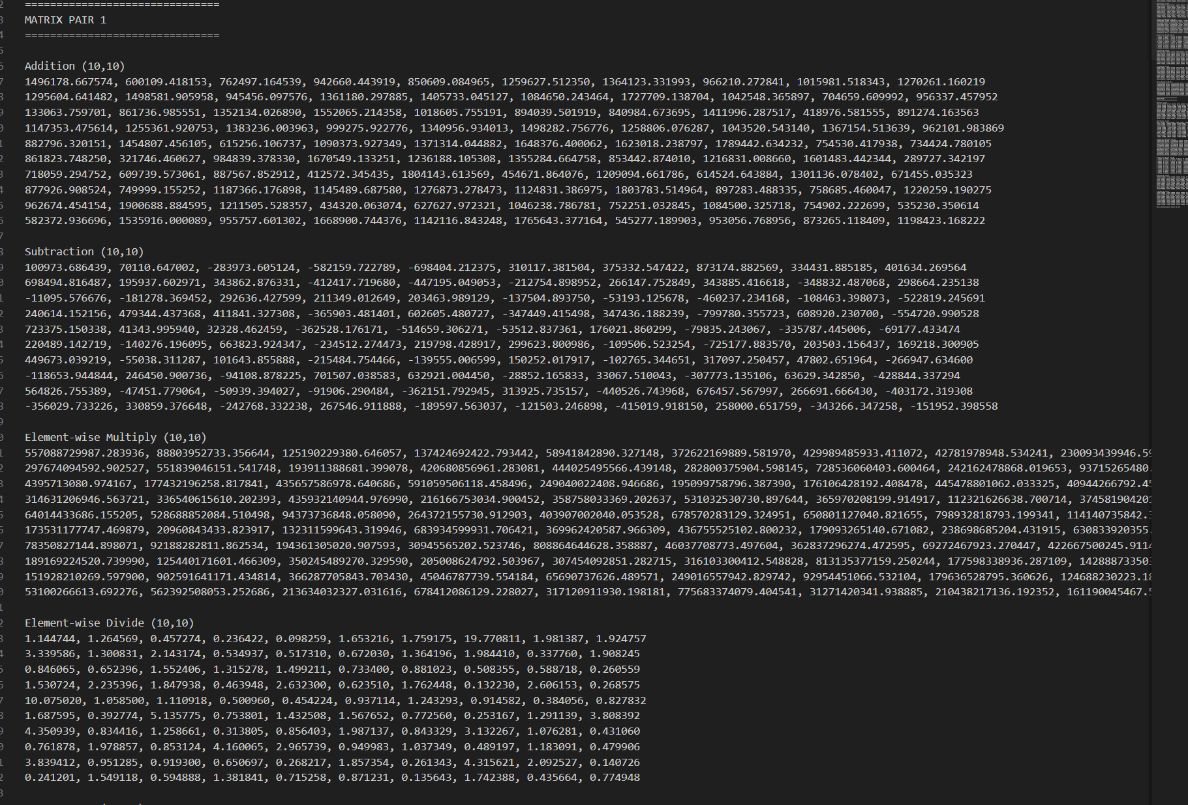
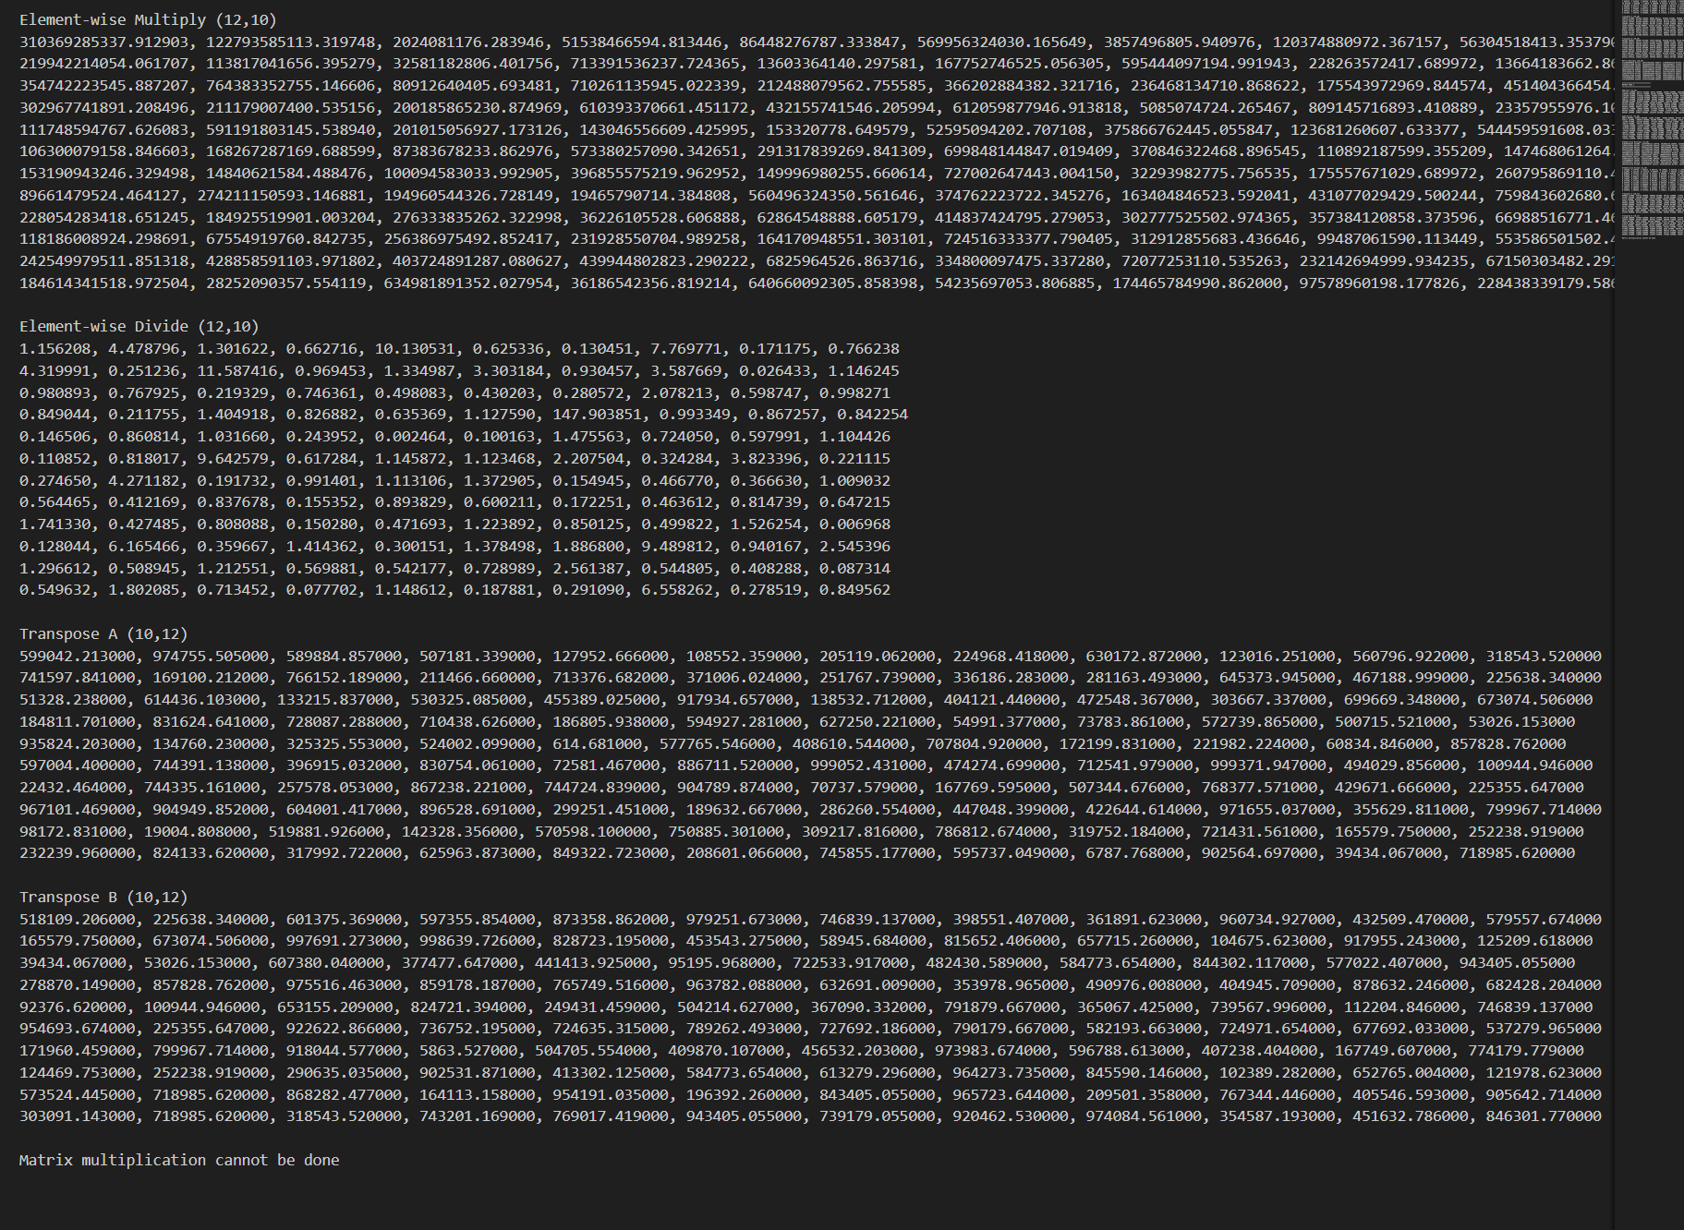

MatData
- Input file :Matdata
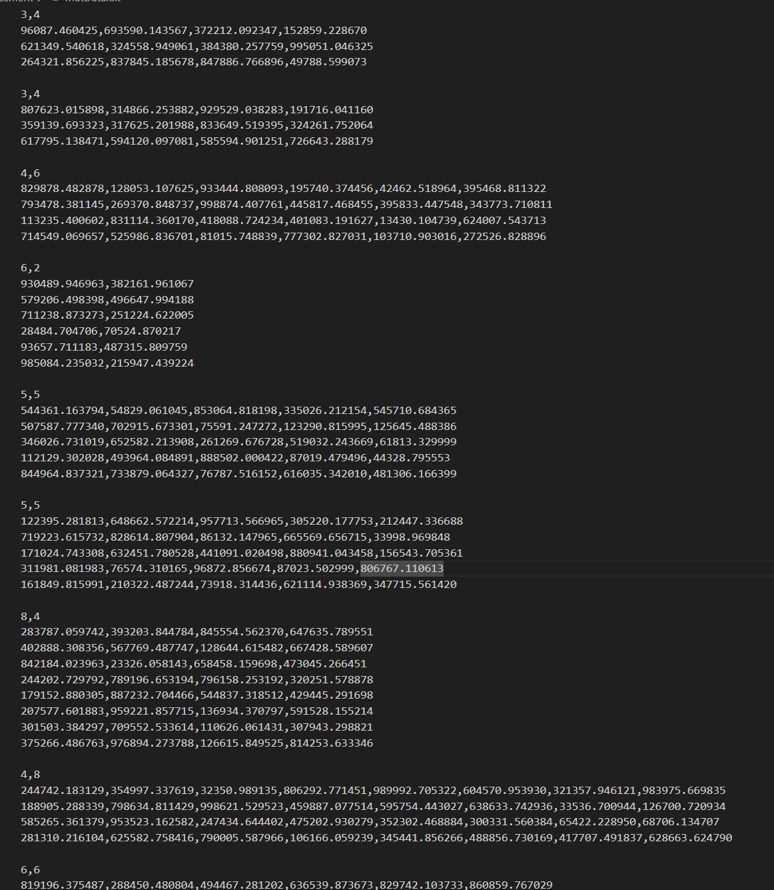

- MatData.txt with 2 threads
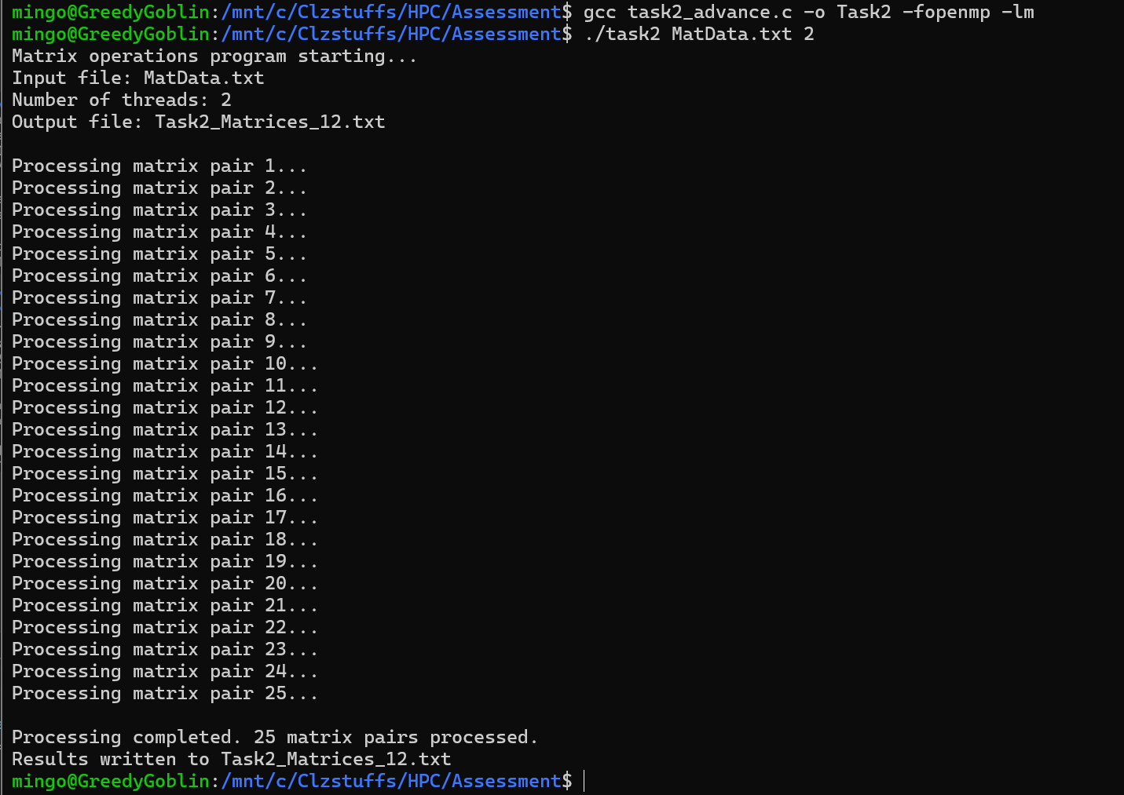
- MatData.txt with 6 threads
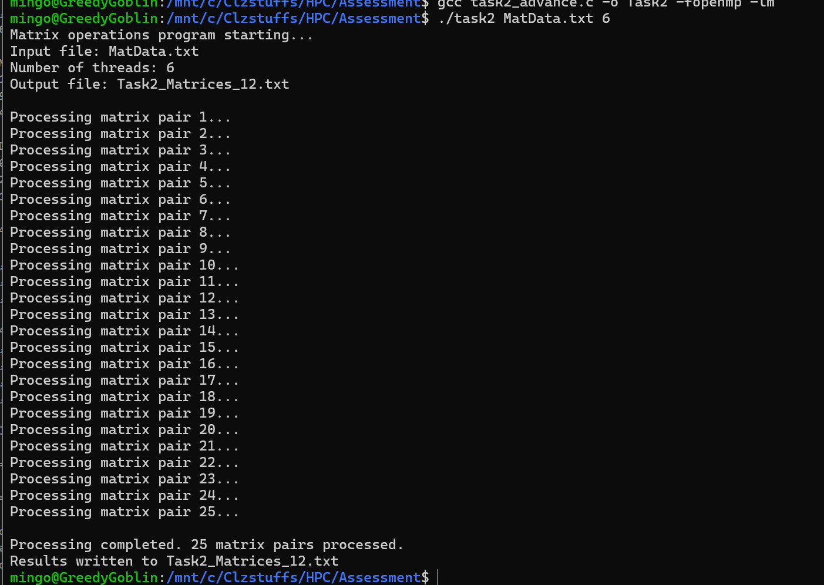

Ooutput:
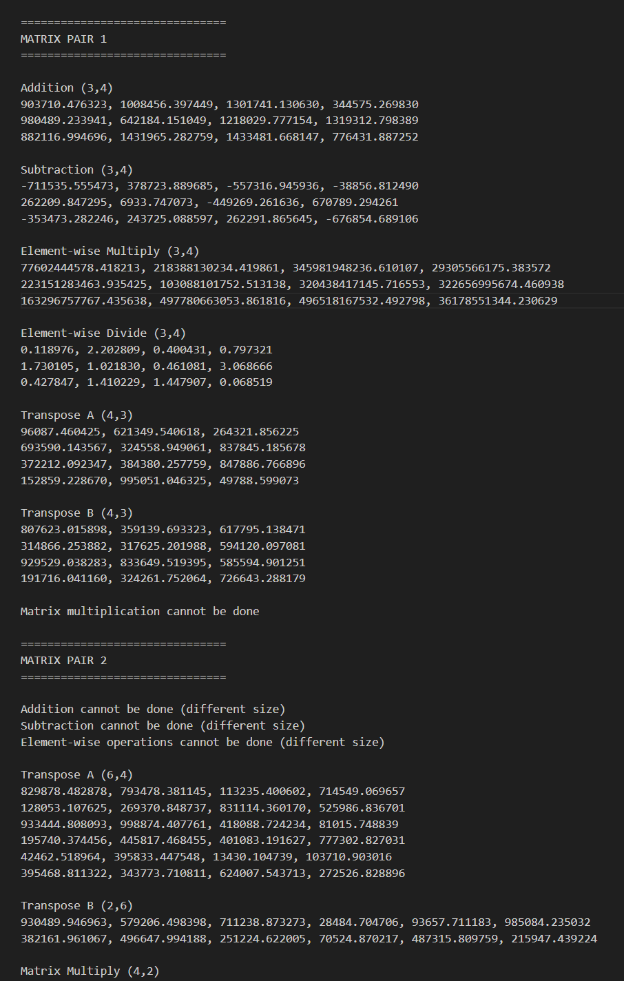

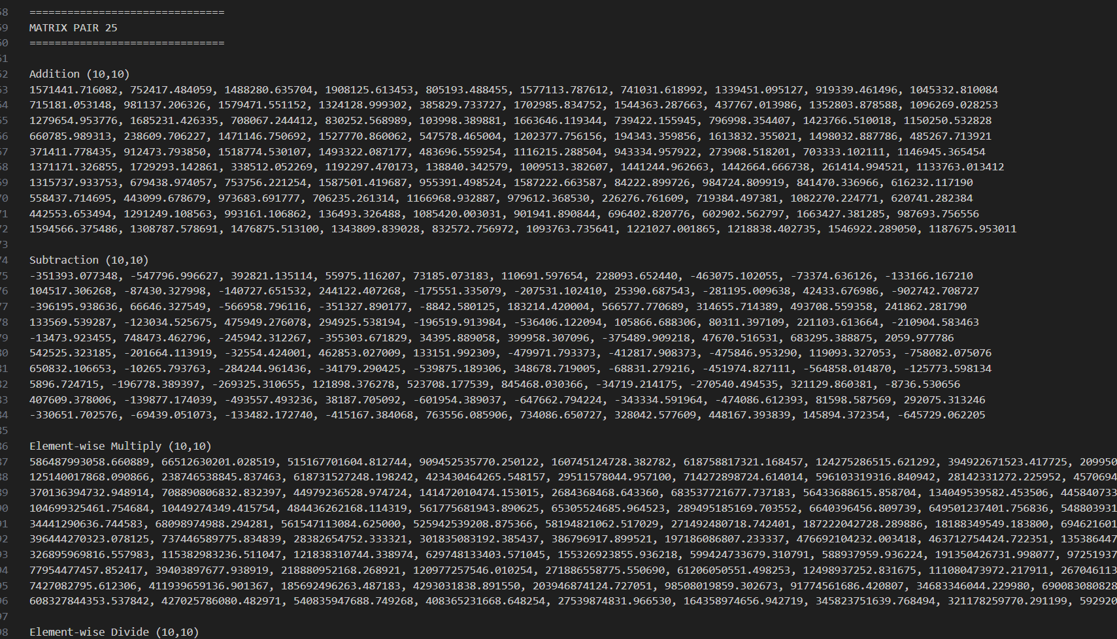

Limitations and Notes
- Performance gains are limited for very small matrices due to OpenMP thread overhead.
- Floating-point precision may introduce minor rounding errors for large numerical values.
- The program assumes correctly formatted input files and does not handle malformed data.
- Sparse matrices are treated as dense matrices, which may lead to inefficient memory usage.
- The implementation is limited to shared-memory systems and does not scale to distributed environments.

Source code
#include <stdio.h>
#include <stdlib.h>
#include <omp.h>
#include <math.h>

double **allocMatrix(int r, int c) {
double **m = malloc(r * sizeof(double *));
for (int i = 0; i < r; i++)
m[i] = malloc(c * sizeof(double));
return m;
}

void freeMatrix(double **m, int r) {
for (int i = 0; i < r; i++)
free(m[i]);
free(m);
}

void printMatrix(FILE *f, double **m, int r, int c) {
for (int i = 0; i < r; i++) {
for (int j = 0; j < c; j++) {
if (isnan(m[i][j]))
fprintf(f, "NaN");
else
fprintf(f, "%lf", m[i][j]);
if (j < c - 1) fprintf(f, ", ");
}
fprintf(f, "\n");
}
}

int capThreads(int req, int max) {
return req < max ? req : max;
}

double **add(double **A, double **B, int r, int c, int t) {
double **R = allocMatrix(r, c);
t = capThreads(t, r);
#pragma omp parallel for num_threads(t)
for (int i = 0; i < r; i++)
for (int j = 0; j < c; j++)
R[i][j] = A[i][j] + B[i][j];
return R;
}

double **sub(double **A, double **B, int r, int c, int t) {
double **R = allocMatrix(r, c);
t = capThreads(t, r);
#pragma omp parallel for num_threads(t)
for (int i = 0; i < r; i++)
for (int j = 0; j < c; j++)
R[i][j] = A[i][j] - B[i][j];
return R;
}

double **elemMul(double **A, double **B, int r, int c, int t) {
double **R = allocMatrix(r, c);
t = capThreads(t, r);
#pragma omp parallel for num_threads(t)
for (int i = 0; i < r; i++)
for (int j = 0; j < c; j++)
R[i][j] = A[i][j] * B[i][j];
return R;
}

double **elemDiv(double **A, double **B, int r, int c, int t) {
double **R = allocMatrix(r, c);
t = capThreads(t, r);
#pragma omp parallel for num_threads(t)
for (int i = 0; i < r; i++)
for (int j = 0; j < c; j++)
R[i][j] = (B[i][j] == 0) ? NAN : A[i][j] / B[i][j];
return R;
}

double **transpose(double **A, int r, int c, int t) {
double **T = allocMatrix(c, r);
t = capThreads(t, r);
#pragma omp parallel for num_threads(t)
for (int i = 0; i < r; i++)
for (int j = 0; j < c; j++)
T[j][i] = A[i][j];
return T;
}

double **matMul(double **A, double **B, int rA, int cA, int cB, int t) {
double **R = allocMatrix(rA, cB);
t = capThreads(t, rA);
#pragma omp parallel for num_threads(t)
for (int i = 0; i < rA; i++) {
for (int j = 0; j < cB; j++) {
double sum = 0;
for (int k = 0; k < cA; k++)
sum += A[i][k] * B[k][j];
R[i][j] = sum;
}
}
return R;
}

int main(int argc, char *argv[]) {
if (argc != 3) {
printf("Usage: ./matrix <file> <threads>\n");
return 1;
}

FILE *in = fopen(argv[1], "r");
if (!in) {
printf("Input file error\n");
return 1;
}

int threads = atoi(argv[2]);
FILE *out = fopen("Task2_MatData_6.txt", "w");

printf("Matrix operations program starting...\n");
printf("Input file: %s\n", argv[1]);
printf("Number of threads: %d\n", threads);
printf("Output file: Task2_Matrices_12.txt\n\n");

int pair = 1;

while (1) {
int r1, c1, r2, c2;
if (fscanf(in, "%d,%d", &r1, &c1) != 2) break;

double **A = allocMatrix(r1, c1);
for (int i = 0; i < r1; i++)
for (int j = 0; j < c1; j++)
fscanf(in, "%lf,", &A[i][j]);

if (fscanf(in, "%d,%d", &r2, &c2) != 2) break;

double **B = allocMatrix(r2, c2);
for (int i = 0; i < r2; i++)
for (int j = 0; j < c2; j++)
fscanf(in, "%lf,", &B[i][j]);

printf("Processing matrix pair %d...\n", pair);

fprintf(out, "\n===============================\n");
fprintf(out, "MATRIX PAIR %d\n", pair++);
fprintf(out, "===============================\n\n");

if (r1 == r2 && c1 == c2) {
fprintf(out, "Addition (%d,%d)\n", r1, c1);
double **R = add(A, B, r1, c1, threads);
printMatrix(out, R, r1, c1);
freeMatrix(R, r1);

fprintf(out, "\nSubtraction (%d,%d)\n", r1, c1);
R = sub(A, B, r1, c1, threads);
printMatrix(out, R, r1, c1);
freeMatrix(R, r1);

fprintf(out, "\nElement-wise Multiply (%d,%d)\n", r1, c1);
R = elemMul(A, B, r1, c1, threads);
printMatrix(out, R, r1, c1);
freeMatrix(R, r1);

fprintf(out, "\nElement-wise Divide (%d,%d)\n", r1, c1);
R = elemDiv(A, B, r1, c1, threads);
printMatrix(out, R, r1, c1);
freeMatrix(R, r1);
} else {
fprintf(out, "Addition cannot be done (different size)\n");
fprintf(out, "Subtraction cannot be done (different size)\n");
fprintf(out, "Element-wise operations cannot be done (different size)\n");
}

fprintf(out, "\nTranspose A (%d,%d)\n", c1, r1);
double **T = transpose(A, r1, c1, threads);
printMatrix(out, T, c1, r1);
freeMatrix(T, c1);

fprintf(out, "\nTranspose B (%d,%d)\n", c2, r2);
T = transpose(B, r2, c2, threads);
printMatrix(out, T, c2, r2);
freeMatrix(T, c2);

if (c1 == r2) {
fprintf(out, "\nMatrix Multiply (%d,%d)\n", r1, c2);
double **R = matMul(A, B, r1, c1, c2, threads);
printMatrix(out, R, r1, c2);
freeMatrix(R, r1);
} else {
fprintf(out, "\nMatrix multiplication cannot be done\n");
}

freeMatrix(A, r1);
freeMatrix(B, r2);
}

printf("\nProcessing completed. %d matrix pairs processed.\n", pair - 1);
printf("Results written to Task2_Matrices_12.txt\n");

fclose(in);
fclose(out);
return 0;
}

Code Structure Overview
Library Utilization:The program is based on the use of OpenMP libraries along with standard C libraries that provide support of file manipulation, dynamic memory allocation, and arithmetic operations. Complete parallel processing and mathematical are supported by a set of header files such as stdio.h, stdlib.h, math.h, and omp.h.
Common Data Structures:Dynamically allocated two-dimensional doubled arrays the type of which is double (**) represent matrices. Each matrix is propagated with the value of its dimensions and the number of threads to ensure that the execution on what is being analysed is homogenous.
Memory utilities: Memory management utilities are applications that permit users to monitor the memory usage of their systems.<|human|>Memory Management Utilities
Mathematically, allocation and deallocation of matrices are done through functions allocMatrix and free Matrix. The utilities enable the safe processing of matrices of all sizes and prevents the leakage of memory.
Parallel computation routines A parallel computer consists of multiple processors executing identical instructions simultaneously using separate data sets.<|human|>Parallel calculation routines A parallel computer is a group of several computers, as shown by distinct sets of data, all executing the same instructions at the same point in time.
Performing operations like: matrix addition, subtraction, element-wise multiplication and division, transposition and standard matrix multiplication are individual functions. Parallelisation of the most computationally intensive loops is done by the OpenMP directive, #pragma omp parallel for.
Thread Control Utility:The cap threads () command limits the number of OpenMP threads depending on the size of the matrices and thus, helps to counteract the over-threading inefficiencies in the operation of small size matrices.
Output Handling Utility:The printMatrix() method writes the output of a matrix in an organized format to an output file and is used to print values which are numerically invalid like those of division by zero.
Main Routine
The primary routine reads command line parameters, reads the matrices in pairs provided in the input file, determines the correctness of the operations based on the dimensional compatibility, performs each of the supported operations with the OpenMP parallelisation and writes the resulted matrices in the output file and releases the memory it used on completion of every two matrices.

